|  |
| --- |
| US Department of Labor  office of labor-management standards |
| LM-10 Electronic Form |
| Functional Requirements |
| Release v1.0 |
|  |

**Revision History**

|  |  |  |  |
| --- | --- | --- | --- |
| **Date** | **Revision** | **Description** | **Author** |
| **07/06/2018** | **1.0** | **Initial Draft** | **Bineeta Adityan** |
| **02/12/2019** | **1.1** | **Updated based on the review meeting (meeting minutes attached)** | **Bineeta Adityan** |
|  |  |  |  |

**Contents**

1. Background 1

2. Project Description 1

3. Purpose 1

3.1. Definitions, Acronyms, Abbreviations 1

3.2. References 2

4. FUNCTIONAL REQUIREMENTS 2

4.1. Login 2

4.1.1. Business Requirements 2

4.1.2. Registration Requirements 2

4.2. Page Level Requirements 3

4.2.1. Page 1 3

4.2.1.1. Business Requirements 3

4.2.1.2. Functional Requirements 3

4.2.1.3. Header Section 3

4.2.1.4. Footer Section 3

4.2.1.5. Design 3

4.2.1.6. Requirements 4

4.2.1.7. Section/Field Level Requirements 4

4.2.2. Page 2 9

4.2.2.1. Business Requirements 9

4.2.2.2. Functional Requirements 9

4.2.2.3. Header Section 9

4.2.2.4. Footer Section 9

4.2.2.5. Design 9

4.2.2.6. Requirements 10

4.2.2.7. Section/Field Level Requirements 10

4.2.3. Page 3 – 12

4.2.3.1. Business Requirements 12

4.2.3.2. Functional Requirements 12

4.2.3.3. Header Section 13

4.2.3.4. Footer Section 13

4.2.3.5. Design 13

4.2.3.6. Requirements 14

4.2.4. Validation Summary Page 16

4.2.5. Other functionalities 17

5. Requirements Revisions History 17

# Background

The Labor-Management Reporting and Disclosure Act of 1959, as amended (LMRDA), requires public disclosure of specific financial transactions or arrangements made between an employer and one or more of the following: a labor organization, union official, employee, or labor relations consultant. Pursuant to Section 203(a) of the LMRDA, every employer who has engaged in any such transaction or arrangement during the fiscal year must file the Employer Report, Form LM-10.

Currently, Office of Labor-Management Standards’ (OLMS) offers a facsimile of the LM-10 that can be downloaded from the website. Filers must manually complete and sign the LM-10 before mailing a copy to OLMS. Once OLMS receives the document, a DRDA staff member registers receipt of the document in the OLMS Report Tracking System (ORTS) system before the document is shipped to a third-party vendor to be scanned. After scanning the document, the scan vendor returns the scanned image to OLMS, and using ORTS system, the scanned image is uploaded into the e.LORS database. Once an image has been successfully loaded into the e.LORS database, the document is disclosed via OLMS’ Online Public Disclosure Room.

# Project Description

The Electronic Forms System (EFS) is the Office of Labor-Management Standards’ (OLMS) web-based system for completing and submitting labor organization and other reports. Currently, the EFS system is available for submitting LM-2, LM-3, LM-4, LM-30, LM-20 and LM-21 filers. The goal for the management is to make the system available to all other annual reports to help reduce the number of paper submissions.

# Purpose

The purpose of this project is to create the electronic version of the LM-10 report. Electronic LM-10s will be available via the EFS system.

# Definitions, Acronyms, Abbreviations

The following is a list of commonly used acronyms used throughout this document:

| Term | Definition |
| --- | --- |
| DOL | Department of Labor |
| e.LORS (5.14) | Electronic Labor Organizations and Reports System |
| FRD | Functional Requirements Document |
| OLMS | Office of Labor-Management and Standards |
| OMB | Office of Management and Budget |
| PO | Program Office |
| RD | Regional Director |
| SQL | Structured Query Language |
| EFS | Electronic Filing System |
| LM | Labor Management |
| ORTS | OLMS Report Tracking System |
| LMRDA | Labor-Management Reporting and Disclosure Act |
| Filer | Users who prepare and sign the form |
| Preparer | Users who prepare the form |
| HTML link | HyperText Markup Language link |
| DIS | Division of Interpretations and Standards |

# References

* LM-10 PDF form
* LM-10 Instructions document

# FUNCTIONAL REQUIREMENTS

* The preparer or filer shall register his/her user account in EFS system to prepare and submit the LM-10 form.
* The filer or preparer shall be able to start a new form or access all in-progress forms.
* The system will have the field level and form level validation rules to authenticate the data before the submission.

# Login

The EFS system will have a link to navigate to the LM-10 user interface. The filer or preparer may create a new account or may use an already existing account to access the form.

# Business Requirements

An employer is required to file only one Form LM-10 each fiscal year that covers all instances of reportable activity even if activity occurs at multiple locations. To submit an LM-10, the filer must have a File Number associated to his/her organization and an Access Key to obtain their electronic LM form

# Registration Requirements

A filer or a preparer of the special reports who has not registered in EFS shall be able to register themselves using the EFS user registration module.

Filers or preparers of a special report shall be able to register themselves in the EFS system using the ***EFS User Registration module*** and choose a user id and password which can be used later to access the LM-10 report. For the detail requirements, refer Filer Registration Requirements document.

# Page Level Requirements

Page level requirements and the validation rules for each page are detailed throughout this document.

# Page 1

# Business Requirements

Page 1 captures the information about the reporting individual/organization. After beginning a new LM-10 form successfully, the EFS system will prefill the information provided by the filer during the registration in Item #1 and item #3 of LM-10. The system will allow the filer to modify all of this information except the File Number and the Employer field.

# Functional Requirements

System shall display ‘Page 1’ in the following states.

* When the filer open an LM-10 form.
* When the filer selects the “<” (PREVIOUS)’ button on PART A
* When the filer selects the ‘MAIN’ link from Left Navigation Panel

# Header Section

The header and footer items pictured below will be displayed on Page 1.

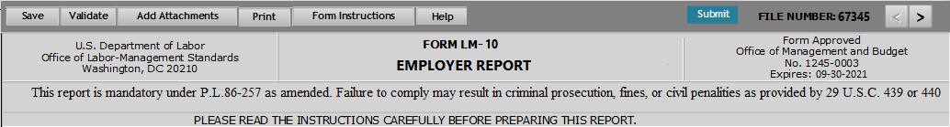

# Footer Section



# Design

A mock-up design for Page #1 is displayed below.

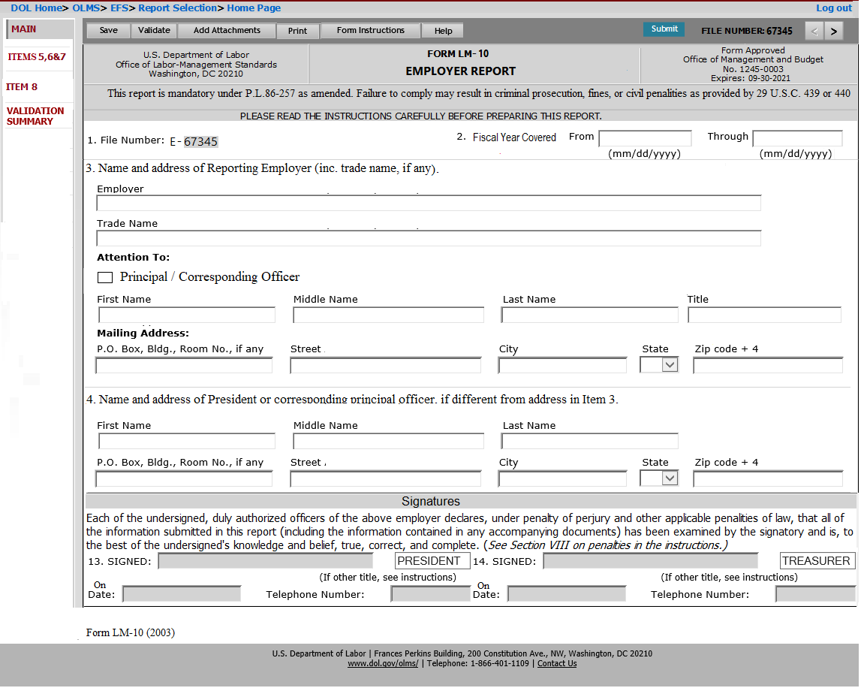

# Requirements

MAIN (Page #1) is the landing page when the filer create a new LM-10 or work on an existing LM-10. The system will pre-populate data available in the eLORS database in the corresponding fields upon loading the page. Items 1-4 along with the signature section will be listed in this page.

The required fields are marked in the following screen mock-up. 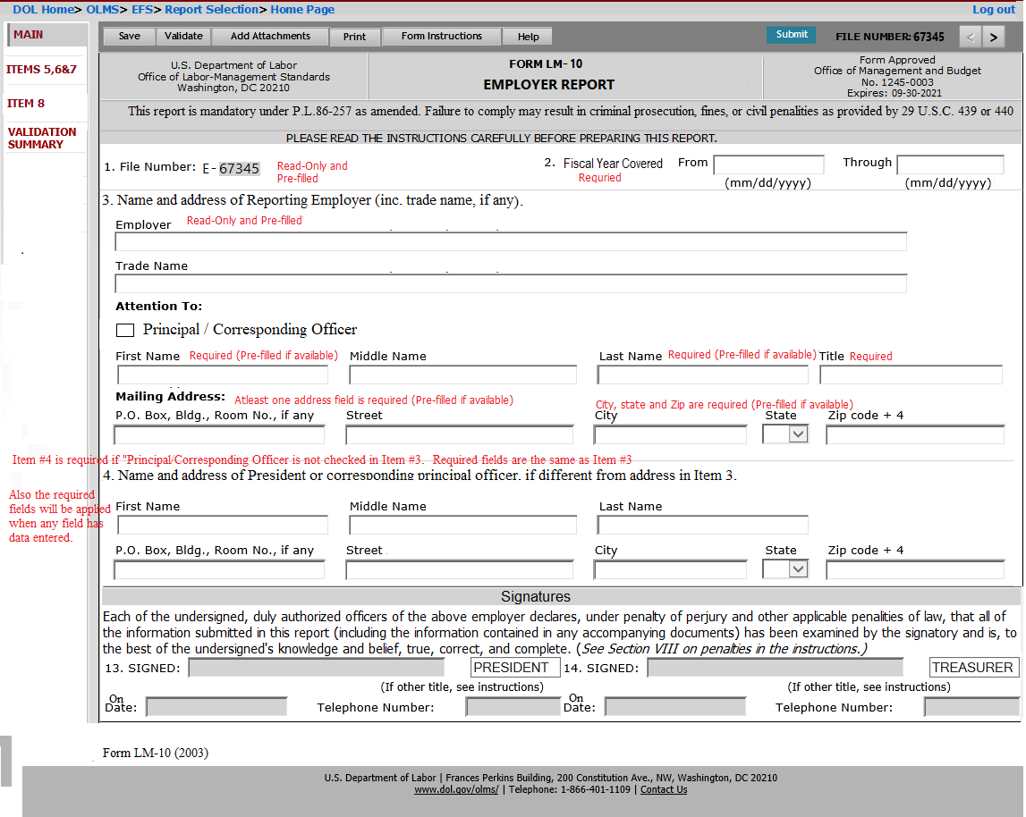

# Section/Field Level Requirements

* **1 –File number. E** - The system will pre-fill the file number assigned to the employer when the form is started. This field will be read-only.
* **2. Fiscal Year Covered:** - The following two date fields will be listed in this section.
  + **From:** - This will be a date field to enter the beginning date of the fiscal year covered in the report. The format for the field should be MM/DD/YYYY.
  + **Through:** - This will be a date field to enter the ending date of the fiscal year covered in the report. The format for the field should be MM/DD/YYYY.
  + The period covered should not be more than 12 months and both dates should not be a future date.
* **3.** **Name and address of Reporting Employer (inc. trade name, if any).** – This section will list the name and address of the reporting employer. Fields listed in this section and the requirements are described below:
* **Employer** – This will be a text field to enter the reporting Employer’s name/Organization Name. The field will be pre-filled upon successful login and will remail read-only.
* **Trade Name** – This will be a text field to enter the trade or commercial name.
* **Attention To** - The following fields will be listed under this title.
  + **Principal/Corresponding Officer** – This is a check box field to identify if the person listed in Item #3 is the principal or corresponding officer.
  + **First Name** – This will be a text field to enter the First Name of the person to whom mail should be directed. The field will be pre-filled upon successful login. The filer will be able to modify the information.
  + **Middle Name** - This will be a text field to enter the Middle Name of the person to whom mail should be directed. The field will be pre-filled upon successful login. The filer will be able to modify the information.
  + **Last Name** - This will be a text field to enter the Last Name of the person to whom mail should be directed. The field will be pre-filled upon successful login. The filer will be able to modify the information.
  + **Title** - This will be a text field to enter the job title of the person to whom mail should be directed. The field will be pre-filled upon successful login if this data is available in the eLors database. The filer will be able to modify the information.
* **Mailing Address** – The following fields will be listed under this title.
  + **P.O. Box, Bldg., Room No., if any** - This will be a text field to enter the P.O Box or Building/room number. The field will be pre-filled upon successful login. The filer will be able to modify the information.
  + **Street** - This will be a text field to enter the street address which the mail should be directed. The field will be pre-filled upon successful login. The filer will be able to modify the information.
  + **City**- This will be a text field to enter the name of the City. The field will be pre-filled upon successful login. The filer will be able to modify the information.
  + **State** - This will be a drop-down field to enter the State. The field will be pre-filled upon successful login. The filer will be able to modify the information. The drop down must list of all states code plus '00' for a non-state.
  + **Zip Code** **+4** – This will be a text field in 5 +4 format (xxxxx-xxxx). The field will be pre-filled upon successful login. The filer will be able to modify the information.
  + **4. Name and Address of President or corresponding principal officer, if different from address in Item 3:** – This section/field will be used to report the details of the president or corresponding principal officer if it is different from the address in Item 3.

The system will not pre-fill data in these fields. Fields listed in this section and its requirements are described below:

* **First Name** – This will be a text field to enter the First Name of the individual.
* **Middle Name** - This will be a text field to enter the Middle Name of the individual.
* **Last Name** - This will be a text field to enter the Last Name of the individual.
* **P.O. Box, Bldg., Room No., if any** - This will be a text field to enter the P.O Box or Building/room number.
* **Street** - This will be a text field to enter the street address which the mail should be directed.
* **City**- This will be a text field to enter the name of the City.
* **State** - This will be a drop-down field to enter the State. The drop down must list of all states code plus '00' for a non-state.
* **Zip Code +4** – This will be a numeric field in 5 +4 format (xxxxx-xxxx).
  + **Signatures** – This section will be listed in page 1. The following requirements are applicable to this section
* The signature section will be enabled only when the form validation completes without any errors.
* If the filer has checked the option “Individual” in section “7.Type of organization”, then only one signature is required to submit the form. For all other options, both the president and the treasurer, or the corresponding principal officers, of the reporting organization must sign the completed Form LM-10.
* **Submit** button will be enabled when successfully entering the signature.

The field level requirements in this section is listed below:

* **13. SIGNED & 14. SIGNED**- The system will list two **SIGNED** fields for getting two set of signatures. Once the form is ready to sign, the system will enable these fields.

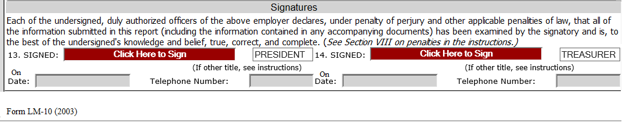

When the filer clicks on the field “**Click Here to Sign”** the following pop-up will be opened.

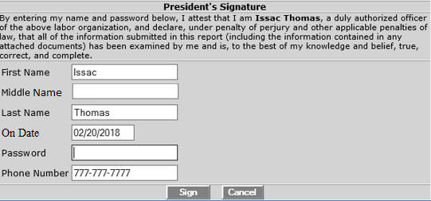

The pop-up will list the title of the filer on the header. The window will list the following disclaimer statement.

“**By entering my name and password below, I attest that I am <First Name Last Name>, a duly authorized officer of the above labor organization, and declare, under penalty of perjury and other applicable penalties of law, that all of the information submitted in this report (including the information contained in any attached documents) has been examined by me and is, to the best of my knowledge and belief, true, correct, and complete.”**

Following fields will be listed in this pop-up window. The filer should be able to modify any information listed in this pop-up.

* **First Name** – The field will list the first name of the filer. The filer should be able to modify this field before signing the form.
* **Middle Name** – The field will list the middle name of the filer. The filer should be able to modify this field before signing the form.
* **Last Name** – The field will list the last name of the filer. The filer should be able to modify this field before signing the form.
* **On Date** – The field will list the current date in DD/MM/YYYY format. The filer should be able to modify this field before signing the form.
* **Password** – The field will capture the password for the account which the filer used while login to the LM-10 form.
* **Phone Number** - The field will list the structurally valid U.S. Telephone numbers (including area code). The filer should be able to modify this field before signing the form
* **Sign** – If the filer has entered the valid password, clicking this button will sign the form. If a wrong password is entered, the system will give a message to the filer regarding the incorrect password and will not allow the filer to sign the form (See validation document for the error message).
* **Cancel** – This button will close the pop-up window

The following titles will be listed against each signature fields. The requirements for each title fields are listed below:

* **President’s Title** - The system shall pre-fill the designation of first signing official as ‘**President’**. The user should be able to modify the title before signing the form. Modifying the title will remove signatures and the form needs to be revalidated to enable the signature field.
* **Treasurer’s Title** - The system shall pre-fill the designation of second signing official as ‘**Treasurer’**. The user should be able to modify the title before signing the form. Modifying the title will remove signatures and the form needs to be revalidated to enable the signature field.

The Date and Telephone will be listed against each signature fields. The requirements for these fields are listed below:

* **On Date** - This field is populated with the date when the filer successfully signs the form. The system list the date on the pop-up window that captures the signature. The filer will be able to modify the date only when signing the form. Once the system captured the signature, the date fields will be read-only.
* **Telephone** - This field is populated with the telephone number of the filer when the filer successfully signs the form. This phone number shall be editable only through the pop-up window that captures the signature. Once the system captured the signature, the field will be read-only.

The pop-up messages to be displayed when capturing the second signature and when clicking the Submit button is listed in the document listed below:



# Page 2

# Business Requirements

ITEM 5,6&7 (Page 2) captures item 5-7.

# Functional Requirements

System shall display ‘ITEM 5,6&7’ in the following states.

* When the filer selects the “>” (PREVIOUS)’ button on MAIN page.
* When the filer selects the “<” (PREVIOUS)’ button on “ITEM 8" page.
* When the filer selects the “ITEMS 5,6&8” link from Left Navigation Panel

# Header Section

The header and footer items pictured below will be displayed on this page



# Footer Section

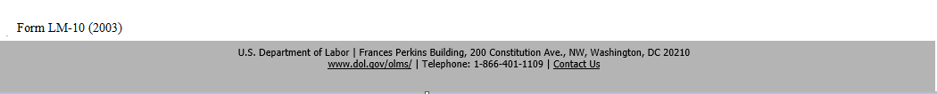

# Design

A mock-up design for ‘ITEM 5,6&7’ is displayed below.

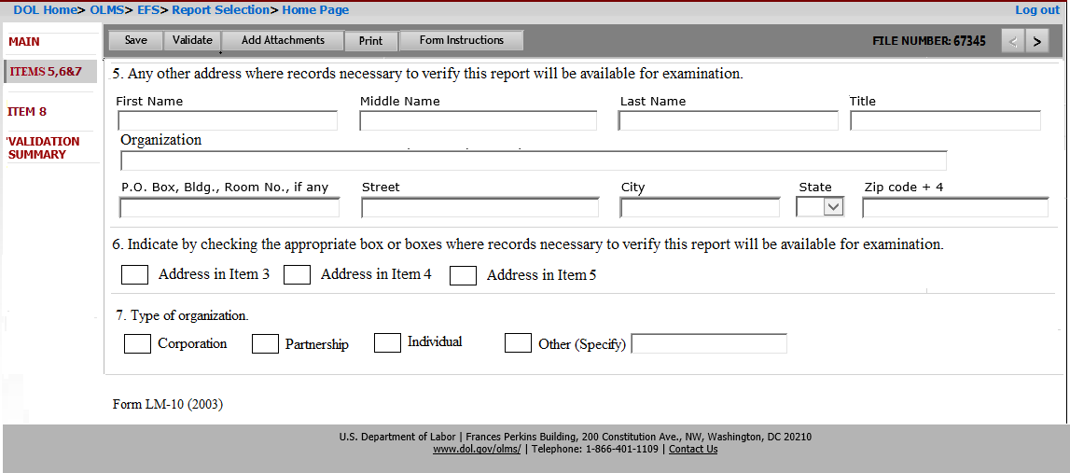

# Requirements

ITEM 5,6&7 captures item 5, 6 and 7. The required fields are marked in the following screen mock-up.

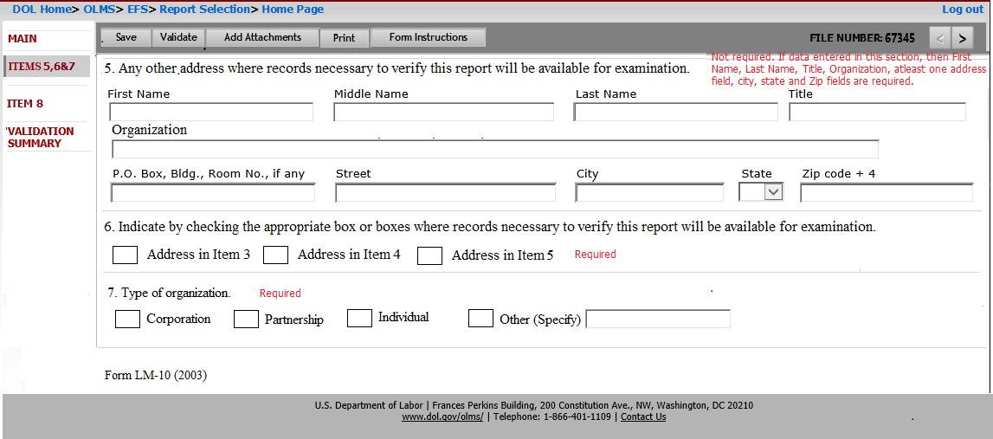

# Section/Field Level Requirements

* **5. Any other address where records necessary to verify this report will be available for examination:** – This section/field will be used to report any other address to be kept in the record.

The system will not pre-fill data in these fields. Fields listed in this section and its requirements are described below:

* **First Name** – This will be a text field to enter the First Name of the individual.
* **Middle Name** - This will be a text field to enter the Middle Name of the individual.
* **Last Name** - This will be a text field to enter the Last Name of the individual.
* **Title** - This will be a text field to enter the Job Title of the individual.
* **Organization** – This will be a text field to enter the organization
* **P.O. Box, Bldg., Room No., if any** - This will be a text field to enter the P.O Box or Building/room number.
* **Street** - This will be a text field to enter the street address which the mail should be directed.
* **City**- This will be a text field to enter the name of the City.
* **State** - This will be a drop-down field to enter the State. The drop down must list of all states code plus '00' for a non-state.
* **Zip Code +4** – This will be a numeric field in 5 +4 format (xxxxx-xxxx).
* **6. Indicate by checking the appropriate box or boxes where records necessary to verify this report will be available for examination.** – The following check boxes will be listed in this section. The filer must select the appropriate boxes.
  + **Address in Item 3**
  + **Address in Item 4**
  + **Address in Item 5**
* **7. Type of Organization** – The following check boxes will be listed to describe the reporting employer.
  + **Corporation**
  + **Partnership**
  + **Individual**
  + **Other** – selectingthis option will openthe “**Specify**” field to enter the type of the organization.

# Page 3

# Business Requirements

ITEM 8 (Page 3) captures the type of reportable activity engaged in by the employer. The page will list the fields 8a to 8f. Each item will have **Yes/No** options to select. The filer needs to fill separate PART B pages for each “Yes” answer selected in this page.

# Functional Requirements

System shall display ‘Page 3’ in the following scenarios.

* When the filer selects “>” (next)’ button on the ‘ITEMS 5,6&7’ page.
* When the filer selects ‘ITEM 8’ link from the Left Navigation Panel.

# Header Section

The header section pictured below will be displayed on Page 2.



# Footer Section

The footer section pictured below will be displayed on Page 2.



# Design

A mock-up design for Page #3 is displayed below.

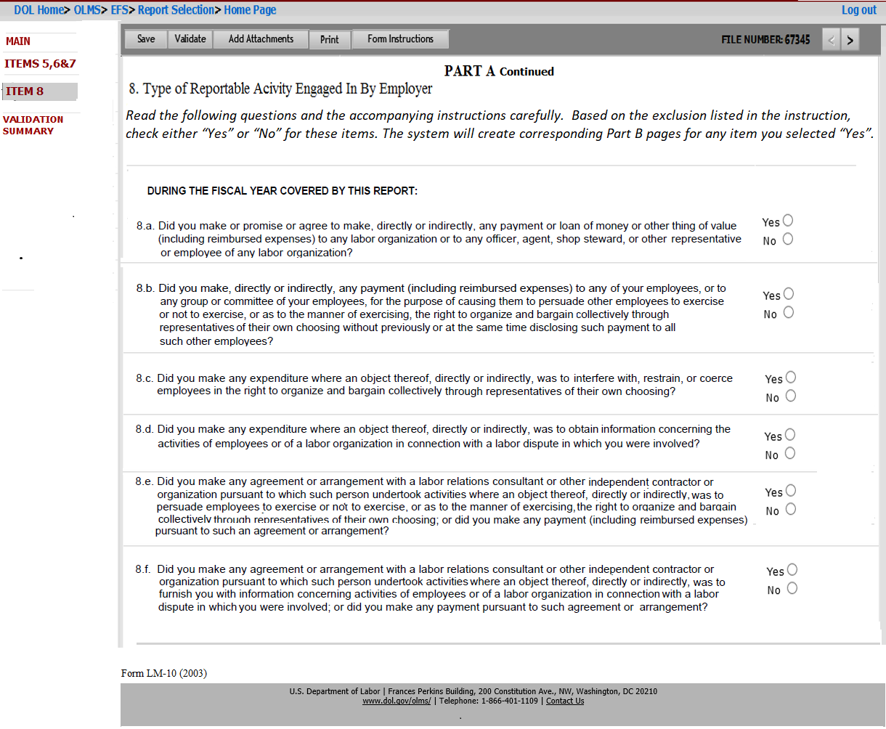

# Requirements

ITEM 8 page list items 8a to 8f. Each item will have Yes and No options. All items in this page is required to be answered.

# Section/Field Level Requirements

*Required fields are marked in the following screen mock-up. 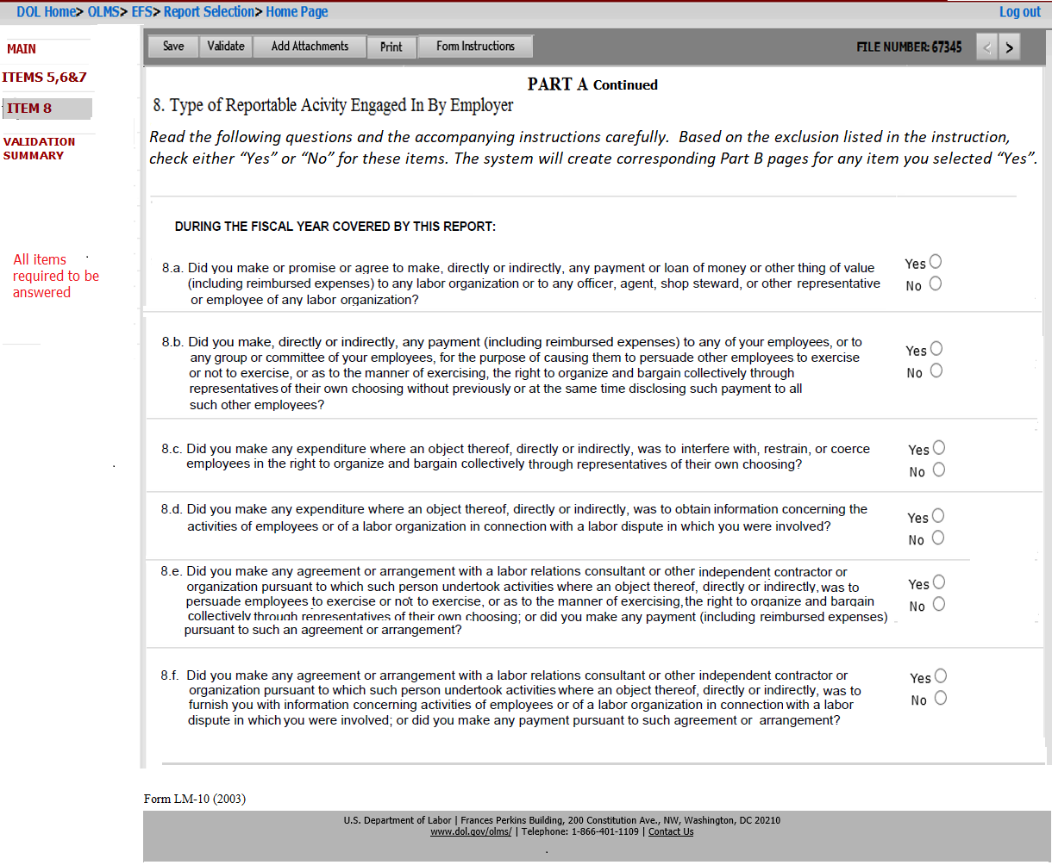

The page will list the title “**PART A continued**”. The header section inside the page should display the following title:

**8. Type of Reportable Activity Engaged In By Employer.**

Under this title, the page will list the following text in Italics:

*Read the following questions and the accompanying instructions carefully. Based on the exclusion listed in the instruction, check wither “Yes” or “No” for these items. The system will create corresponding Part B pages for any item you selected “Yes”.*

The following Items will be listed in this page. Above this list, the following title text should be listed:

“**DURING THE FISCAL YEAR COVERED BY THIS REPORT:”**

Items 8a to 8f are listed below: Each items will have ***Yes*** and ***No*** options to select. The filer must answer this question. The field will also list the following text box.

* **8. a. Did you make or promise or agree to make, directly or indirectly, any payment or loan of money or other thing of value (including reimbursed expenses) to any labor organization or to any officer, agent, shop steward, or other representative or employee of any labor organization?**
* **8. b. Did you make, directly or indirectly, any payment (including reimbursed expenses) to any of your employees, or to any group or committee of your employees, for the purpose of causing them to persuade other employees to exercise or not to exercise, or as to the manner of exercising, the right to organize and bargain collectively through representatives of their own choosing without previously or at the same time disclosing such payment to all such other employees?**
* **8. c. Did you make any expenditure where an object thereof, directly or indirectly, was to interfere with, restrain, or coerce employees in the right to organize and bargain collectively through representatives of their own choosing?**
* **8. d. Did you make any expenditure where an object thereof, directly or indirectly, was to obtain information concerning the activities of employees of a labor organization in connection with a labor dispute in which you were involved?**
* **8. e. Did you make any agreement or arrangement with a labor relations consultant or other independent contractor or organization pursuant to which such person undertook activities where an object thereof, directly or indirectly, was to persuade employees to exercise or not to exercise or as to the manner of exercising the right to organize and bargain collectively though representatives of their own choosing or did you make any payment (including reimbursed expenses) pursuant to such an agreement or arrangement?**
* **8. f. Did you make any agreement or arrangement with a labor relations consultant or other independent contractor or organization pursuant to which such person undertook activities where an object thereof, directly or indirectly, was to furnish you with information concerning activities or employees or of a labor organization in connection with a labor dispute in which you were involved, or did you make any payment pursuant to such agreement or arrangement?**

# Page B

# Business Requirements

Page 4 captures the details of each reportable transaction identified in item 8. The EFS system will not prefill any information in this page.

# Functional Requirements

System shall display page 3 in the following scenarios.

• When the filer selects “>” (next)’ button on PART A

• When the filer selects PART B link from Left Navigation Panel

• When the filer selects “<” (Previous)’ button on the Validation Summary

# Header Section

The header item pictured below will be displayed on Page 3.



# Footer Section

The footer item pictured below will be displayed on Page 3.



# Design

A mock-up design for PART B is pictured below:

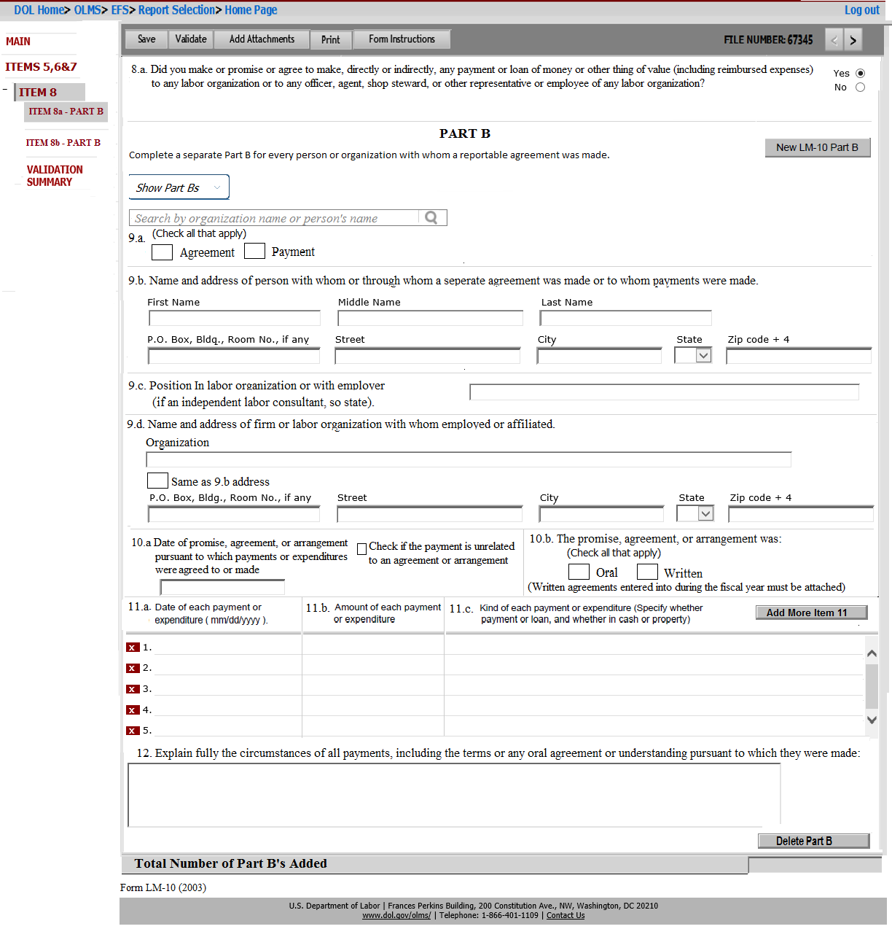

# Requirements

PART B will get created only when the filer check “Yes” on any item listed in ITEM 8(8a-8e) questions. The label for this page should have the corresponding Item 8 identifier listed. For example, if PART B is created for ITEM 8a, then the page label for PART B should be listed as “**ITEM 8a – PART B**”.

The header section on this page should list the corresponding ITEM 8 question and should be Read-only. The filer can only modify the selected answer for this question in ITEM 8 page only.

Required fields are marked in the mock-up below:

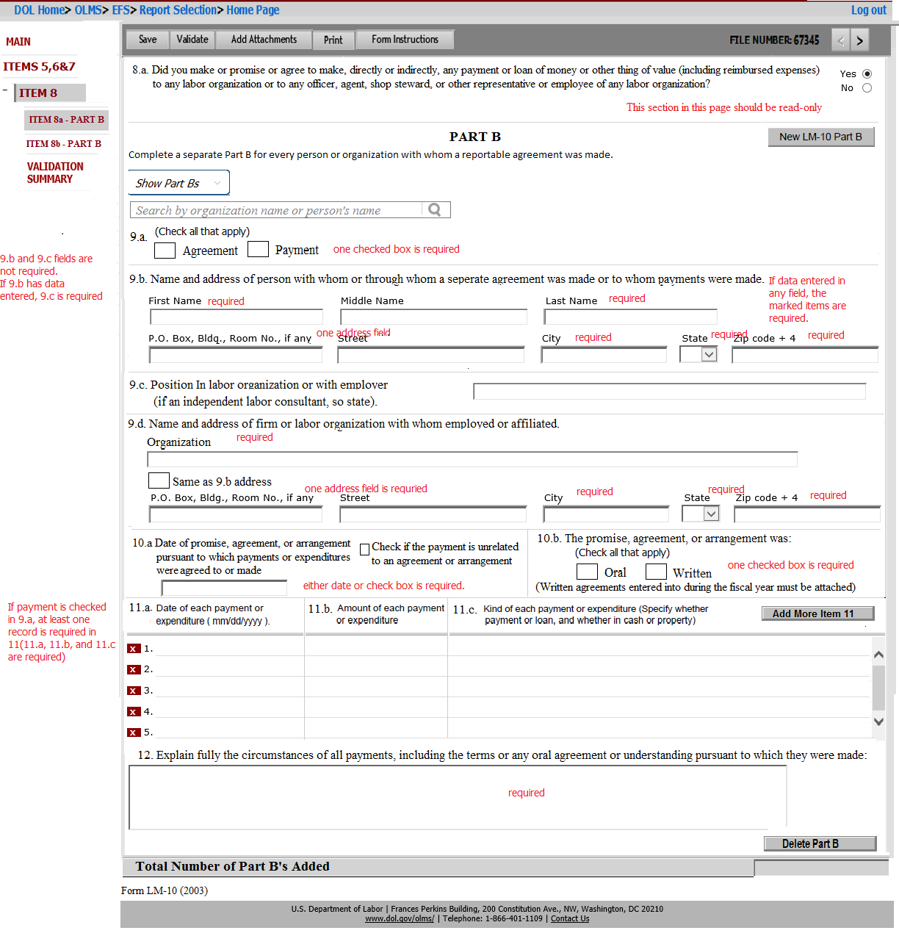

**Title section** – The section should display the title **PART B.** Under the title the following text should be listed in Italics

*“Complete a separate Part B for every person or organization with whom a reportable agreement was made.”*

# Section/Field Level Requirements



* **9. a –** Following check box fields to describe whether the Part B covers an agreement, a payment, or both.
  + **Agreement**
  + **Payment**

The following text should be listed near to the check boxes.

“(Check all that apply)”.

* **9. b. Name and address of person with whom or through whom a separate agreement was made or to whom payments were made. –** The following fields will be listed in this section to enter the name and address of the firm or organization.
  + **First Name -** This will be a text field to enter the first name of the person with whom the agreement was made or whom the payments were made.
  + **Middle Name -** This will be a text field to enter the middle name of the person with whom the agreement was made or whom the payments were made.
  + **Last Name -** This will be a text field to enter the last name of the person with whom the agreement was made or whom the payments were made.
  + **P.O. Box, Bldg., Room No., if any** - This will be a text field to enter the P.O Box or Building/room number.
  + **Street** - This will be a text field to enter the street address of the person whom the payment was made
  + **City**- This will be a text field to enter the name of the City.
  + **State** - This will be a drop-down field to enter the State. The drop down must list of all states code plus '00' for a non-state.
  + **Zip Code** **+4** – This will be a text field in 5 +4 format (xxxxx-xxxx).
* **9. c. Position in labor organization or with employer (if an independent labor consultant, so state). –** This will be a text field to enter the position title of the person listed in item 9.b.
* **9. d. Name and address of firm or labor organization with whom employed or affiliated. –** The following fields will be listed in this section to enter the name and address of the firm or organization.
  + **Organization –** This will be text field to enter the name of the labor organization to whom payments were made, with whom the agreement or arrangement was made, orwith whom the person listed in item 9.b was employed or affiliated.
  + **Same as 9.b address** – This will be a check box field. When filer check this check box, the address listed in 9.b should be copied to the address fields listed in 9.d.
  + **P.O. Box, Bldg., Room No., if any** - This will be a text field to enter the P.O Box or Building/room number.
  + **Street** - This will be a text field to enter the street.
  + **City**- This will be a text field to enter the name of the City.
  + **State** - This will be a drop-down field to enter the State. The drop down must list of all states code plus '00' for a non-state.
  + **Zip Code** **+4** – This will be a text field in 5 +4 format (xxxxx-xxxx).
* **10. a. Date of the promise, agreement or arrangement pursuant to which payments or expenditures were agreed to or made –** There will be a ***date*** field to enter the date of promise, agreement or arrangement to report. The following check box field should be listed under this section.
  + “**Check if the payment is unrelated to an agreement or arrangement**”- This will a check box field. If the payments are unrelated to an agreement or arrangement, the filer will check this check box.
* **10.b. The promise, agreement, or arrangement was** – the following check boxes will be listed to indicate whether the promise agreement or arrangement was oral, written or both.
  + **Oral**
  + **Written -** if written check box is checked, the filer must attach the written agreement.

The following text should be listed in this section

* (*Written agreements entered into during the fiscal year must be attached.)
* “(Check all that apply)” -This text should be listed near to the check boxes.

The following sections should be listed as a grid line format. By default this section must list 5 blank grid lines.

* **11. a. Date of each payment or expenditure (mm/dd/yyyy) -** This will be a date field to enter the date of the payment listed in Item 9.The format should be mm/dd/yyyy.
* **11. b. Amount of each payment or expenditure -** This will be numeric field to enter the dollar value of each payment. The field should have dollar sign and the comma separation added upon save.
* **11. c. Kind of each payment or expenditure (specify whether payment or loan, and whether in cash or property) -** This will be text field to indicate the description of each payment.

**Additional features for this section is listed below:**

* **Add More Item 11** – Clicking this button will add new lines in 11.a, 11.b and 11.c.
* **Delete Item 11** – Each individual items will have an X button to delete any lines listed. Clicking X button on the first five lines will only clear the data entered in those lines.
* **12. Explain fully the circumstances of all payments, including the terms of any oral agreement or understanding pursuant to which they were made. -** This will be text field to provide a full explanation identifying the purpose and circumstances of the payments, promises, agreements or arrangements included in the report.
* **Total Number of Part B’s Added.** – When saving the page the system will calculate the total number of PART Bs added in the page and will be listed in this field.

# Additional features

This page has additional features included. The features and its requirements are listed below:

* **Search by organization or by name of the person**

The following requirements should be applied to the search feature listing on this page.

1. **The search feature in Part B for 8a questions** should list the data submitted in LM-30s (Item 4 and 5), LM-2s (SCH 11 and 12) and LM-3s (item 24).
2. **PART Bs for 8b, 8c and 8d DO NOT need a search feature**.

* **New LM-10 Part B** - Clicking this button will create a new Part B (All items listed in Part B).
* **Delete LM-10 Part B –** Clicking this button will delete the selected part B
* **Show Part B: Save** feature will add the First Name, Last Name, street, City and State entered in Item 9.b and the Organization entered in 9d to this drop down list.
  + The data format for the drop down will be as follows:
    - **Organization-First Name-Last Name-Street-City-State**

# Validation Summary Page

* The Validation summary page will list all errors, in the order of pages in the LM-10 form.
* Each error will have a Page number, Item number, Row number and error message.
* A hyper link shall be provided along with each error. When user selects this link system shall redirect user to the page/ item that has an error.

# Other functionalities

The following functionalities are common to all the annual reports. LM-10 form will use the same architecture to perform these functionalities.

**Save** – This button will save the current page and the data will be inserted to the EFS temporary database.

**Validate** – This button will all the pages, except the Main page performs the following.

1. Saves the page data to the EFS temporary database
2. Trigger a page level validation and returns any error to be corrected.

**Add Attachments –** The filer will use this button to add any attachments that needs to be submitted along with tier LM-10 form.

**Print** – This button will generate a print preview of the form. The data entered in the form will be listed in the preview. The format for the print preview should be closely matched with the approved report format.

**Submit** – This button will selected as the final step to submit the LM-10 form. The form can be submitted only after the filer signed the form. Once the filer signed the form and clicked on Submit button, the data will be moved from the temporary database to the eLORS database.

**Form Instructions** – This button will open the instructions page in a new tab. DIS will be responsible for providing the HTML version of the LM-10 instructions.

**EFS Help** – This button will open the EFS Help page in a new tab.

# Disclosed Report

All successfully submitted report must be disclosed on the OLMS disclosure site. The report must match with the OMB approved LM-10 form format. The field order and the field title must match.

# Requirements Revisions History

During the requirements discussions and review meetings, requirements for certain sections have been changed. The details are listed in the following table.

| **Date** | **Change Nature** | **Stakeholders Involved** | **Decision/Changes Provided** | **Approved By** | **Comments** |
| --- | --- | --- | --- | --- | --- |
| 01/31/2019 | LM-10 requirements review | Andrew Davis  Christian Myers  Dyana Aziz  Ethan Dazelle |  | Andrew Davis |  |